LAB-2 REPORT
DATA COMMUNICATION AND NETWORK
BIT STUFFING AND DE-STUFFING
Objective
The purpose of this exercise is to demonstrate the concept of Bit Stuffing and De-stuffing using Cisco Packet Tracer, focusing on the visualization of data transmission.
Steps to perform :-
1. Network Setup
- Open Cisco Packet Tracer.
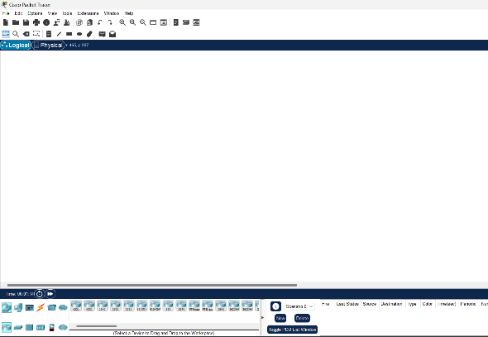
- Add the following devices to the workspace:
2 PCs (e.g., PC0 and PC1).- Represent two end devices that will communicate with each other.
1 Switch (e.g., 2960 Switch). -Allows multiple devices to connect and communicate within the same network.
1 Router (e.g., 1841 Router).- Connects the network and assigns an IP address, enabling communication across devices.
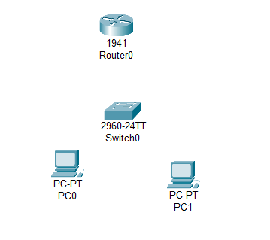
- Establish connections:
PC0 to Switch: Straight-through cable- Used to connect PCs to the switch, as these cables are ideal for connecting different types of devices.
PC1 to Switch: Straight-through cable - Used to connect PCs to the switch, as these cables are ideal for connecting different types of devices.
Switch to Router: Crossover cable- Used between the switch and the router, as both are networking devices of the same type.
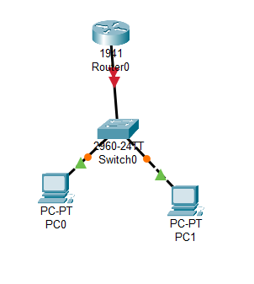

- Network Configuration
Configuration is performed to assign IP addresses and make the devices communicate.
Router Configuration:
- Access the router's CLI.
- Configure the Fast Ethernet interface:
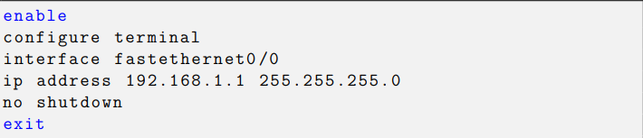
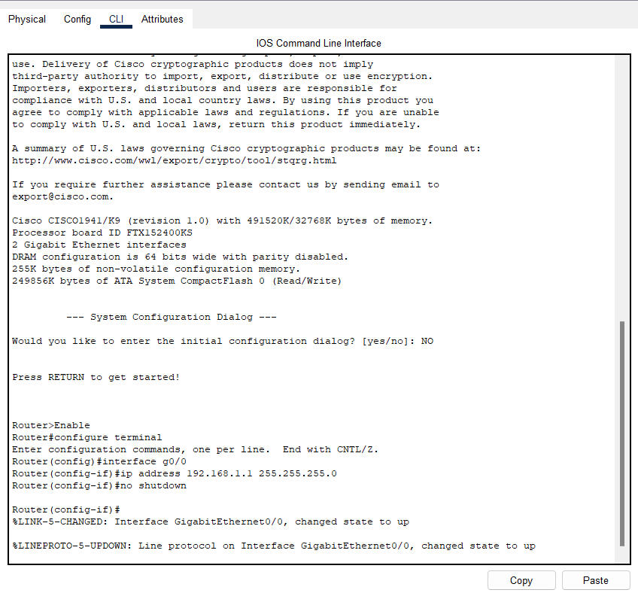
CONNECTED SYSTEM-
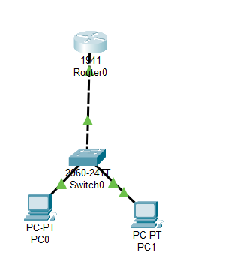

- PC Configuration: Configure the IP addresses on each PC
1-PC0:
IP Address: 192.168.1.2
Subnet Mask: 255.255.255.0
Gateway: 192.168.1.1
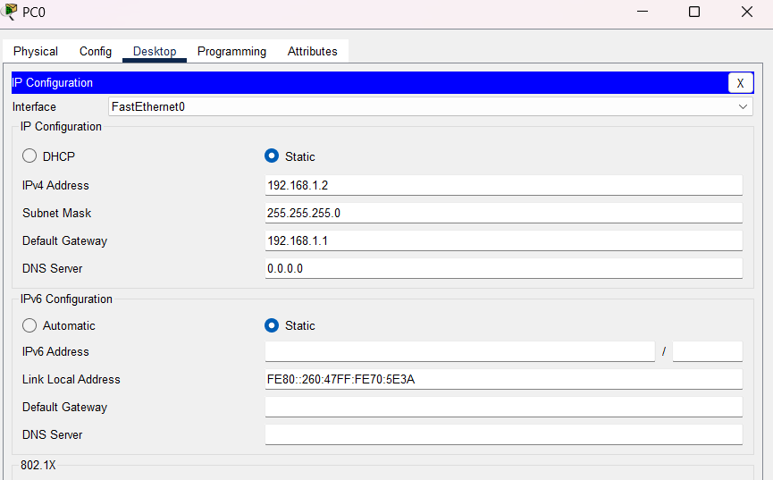
  - PC1:
IP Address: 192.168.1.3
Subnet Mask: 255.255.255.0
Gateway: 192.168.1.1
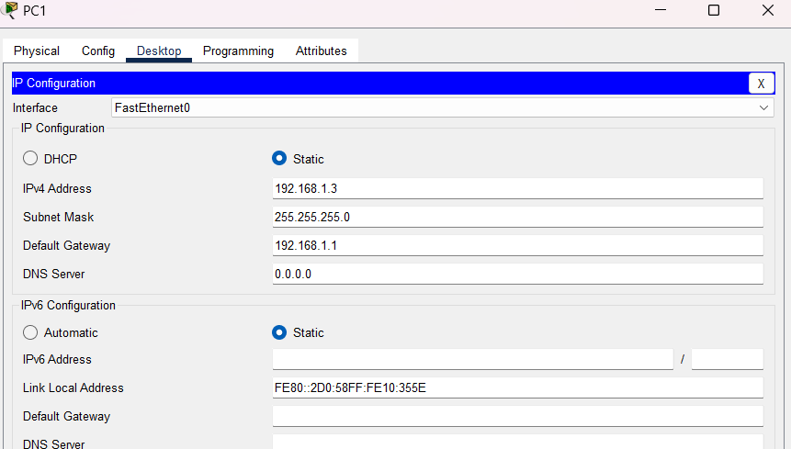
These configurations ensure that the PCs can communicate with each other through the router.
- Simulating Bit Stuffing and De-stuffing
This step focuses on sending and observing data packets to visualize how bit stuffing works:
- Simulation Mode: This mode in Cisco Packet Tracer slows down the communication process, allowing you to see how data packets travel through the network.

- Sending a Custom Packet:
Use the ping command on PC0 to send a message to PC1. The command checks if the network is functioning properly.
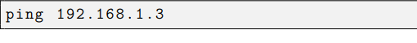
Observe the packet flow in the simulation panel. Bit stuffing will be visible when extra bits are added to ensure proper synchronization of the data.
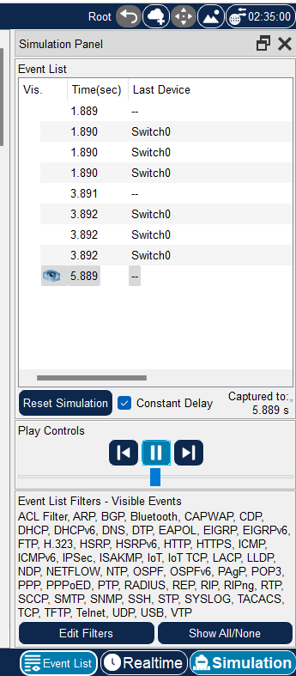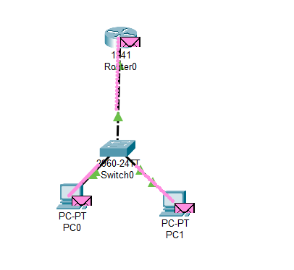
- Verifying Results
After sending the packet, verify that the communication is successful:
- The ping command’s reply confirms that PC0 can reach PC1.
- 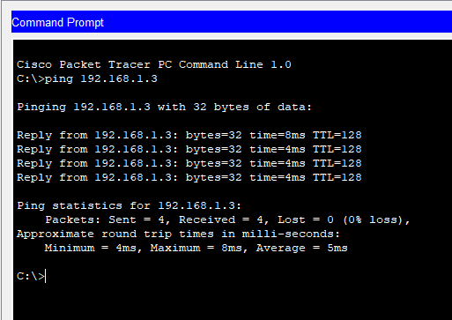
- In the simulation panel, you can observe how bits are added (bit stuffing) and removed (de-stuffing) to maintain synchronization during transmission.
- Saving the Work
Once the lab is completed:-
Save the project in Cisco Packet Tracer with the filename Lab2_BitStuffing.pkt to preserve the network configuration and results for future reference.

Bitstuffing and De-Stuffing outputs from the 3 cases
Bitstuffing- Bit stuffing is a technique used in data communication protocols to ensure that the transmitted data is correctly synchronized between the sender and receiver.
1st case
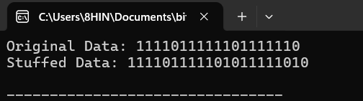
2nd case
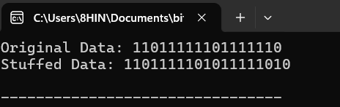
3rd case
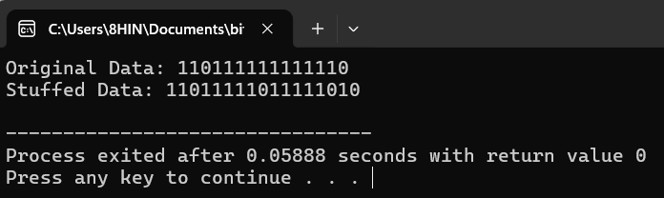
De-stuffing- De-stuffing is the reverse process of bit stuffing, performed at the receiver's end. It involves removing the extra stuffed bits from the data stream to restore the original message.
1st case
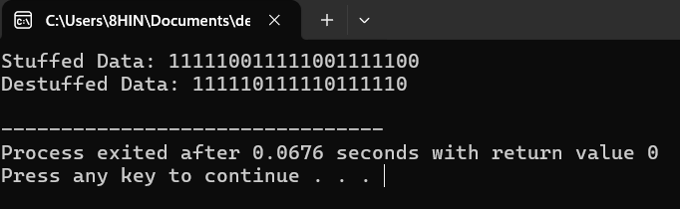
2nd case
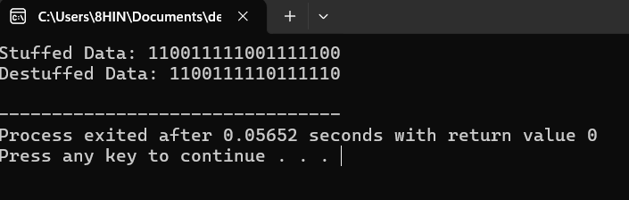
3rd case
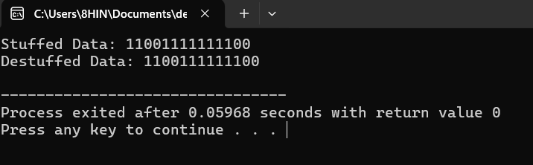

Conclusion-
The lab successfully demonstrates bit stuffing and de-stuffing processes, ensuring synchronization during data transmission and verifying connectivity between network devices also explains the concept of bit stuffing and de-stuffing and the importance of these processes in maintaining accurate communication between devices in a network.

